

Intelligent Mancala Game.

Mohamed Yasser Ahmed code:1601287

Mohamed Atta Ibrahim code :16x0101

Yousef Abdelbadea Ali code:15T0202

Mahmoud Mohamed Benyamin code: 1501367

Hady Ashraf Ragab code:1601636

**Submitted to**

Dr.Manal Morad

# Introduction

The mancala game that is developed in the project has two players, one is the end user and the other is the AI algorithm. The mancala board has six houses for each player and only one mancala for each player. Each house of mancala has four bits in the initial state or other variant numbers in the other states according to the player’s move. The mancala game’s logic in the project supports both stealing and without stealing strategies.

The AI algorithm uses two methods for best player move, the MiniMax method and the MiniMax with alpha_beta pruning.

# Implementation

Gui is implemented using tkinter and we implement Mancala class that contain the following methods:

## Pages:

It contains some methods that are in the table below.

|  |  |
| --- | --- |
| **Method** | **Description** |
| **game_page(self)** | We call this function to initialize the game page with two mancala and twelve houses and four bits for each house. |
| **home(self)** | We call this function to initialize a page that enables the user to choose between AI or multiplayer, stealing or without stealing, and then let’s play. |
| **menu(self)** | This function enables two choices: transfer to the home page or exit from the game absolutely. |

1. Pages Logic:

It contains some of methods:

|  |  |
| --- | --- |
| **Method** | **Description** |
| **update(self):** | We call this function when any change happen in  House place. |
| **Initial_state(self):** | We call it at the start of gaming to put the numbers  In the house's places and mancala for each player. |
| **changepage(self,pagenum):** | This function calls it when changing the pages home page or game page. |
| **choosegame(self,type):** | This method for choosing the type of the game is stealing or without stealing. |

## Game Logic

|  |  |
| --- | --- |
| Method | Description |
| **play_without_steeling(self,house_index):** | It takes a house index that pushed and play mode without stealing. |
| **play_with_steeling(self,house_index):** | It take house index that pushed and play mode with stealing |
| **play_select(self,house_index):** | 1-Houses buttons is called this method.  2- choose between play with steeling or without depend on play_type attribute. |
| **winner(self):** | Decide which one is win. |
| **isGameEnd(self):** | 1-Check if play is ended by check any of 6 houses in same side are zeros.  2- Call winner function. |

1. AI

|  |  |
| --- | --- |
| Method | Description |
| **CalculateState(self,bits,pos,player,stealing)** | Gives the value of bits after one move. |
| **get_diff_score(self,bits):** | Get diff between the two mancalas. |
| **possible_player_moves(self,player):** | Generate possible moves available for the player. |
| **find_all_moves(self,bits,stealing,player=0):** | Get all moves and create their list. |
| **isGameEnd(self,bits):** | Check if all bits of one player are empty. |
| **replay(self,bits,pos,player=0):** | Check if the moves can give you one more turn. |
| **mini_max(self,bits,depth=2, maximizing_player=False,stealing = False):** | Return index for best move using minimax. |
| **mini_max_alpha_beta(self, depth=2, alpha=-999, beta=+999, maximizing_player=False):** | Return index for best move using alpha beta. |

Class Diagram

# 

# 

# 

# 

# 

# User Guide

## Home page

It contains 5 buttons:

* Multiplayer and AI buttons to choose playing with human or computer.
* Stealling and Without-Stealing to choose play mode.
* Let’s play button to go game page.



## Game

In menu bar, It has two buttons Home to return to home page and Exit to close the game. Game page contains 6 homes and 1 mancala for each player.

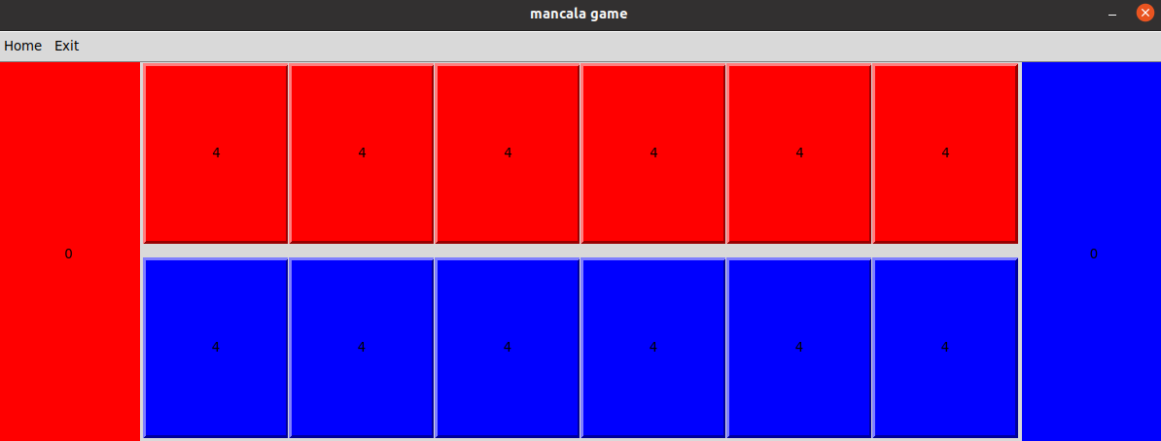

When player wins, It pops up message box that show the winner and then initialize the game to first state.

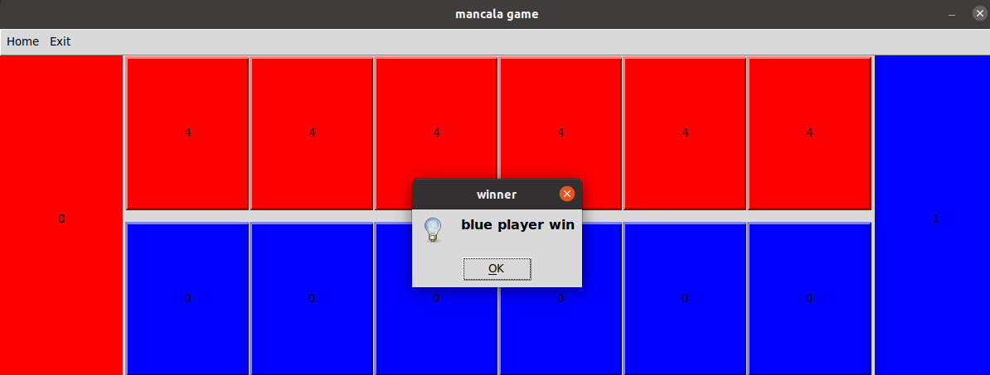

# Role of Each Member

|  |  |
| --- | --- |
| Name | Role |
| Mohamed Yasser Ahmed  Yousef Abdelbadea Ali | GUI |
| Mohamed Atta Ibrahim  Mahmoud Mohamed | AI |
| Hady Ashraf Ragab | Game Logic |

# Important Links

Youtube Link:<https://www.youtube.com/watch?v=9hItzc_5rBA>

Github Link:<https://github.com/Mohamed-A-I/Intelligent-Mancala-Game>